**TEAM NAME: RAYR  
  
LOGO:**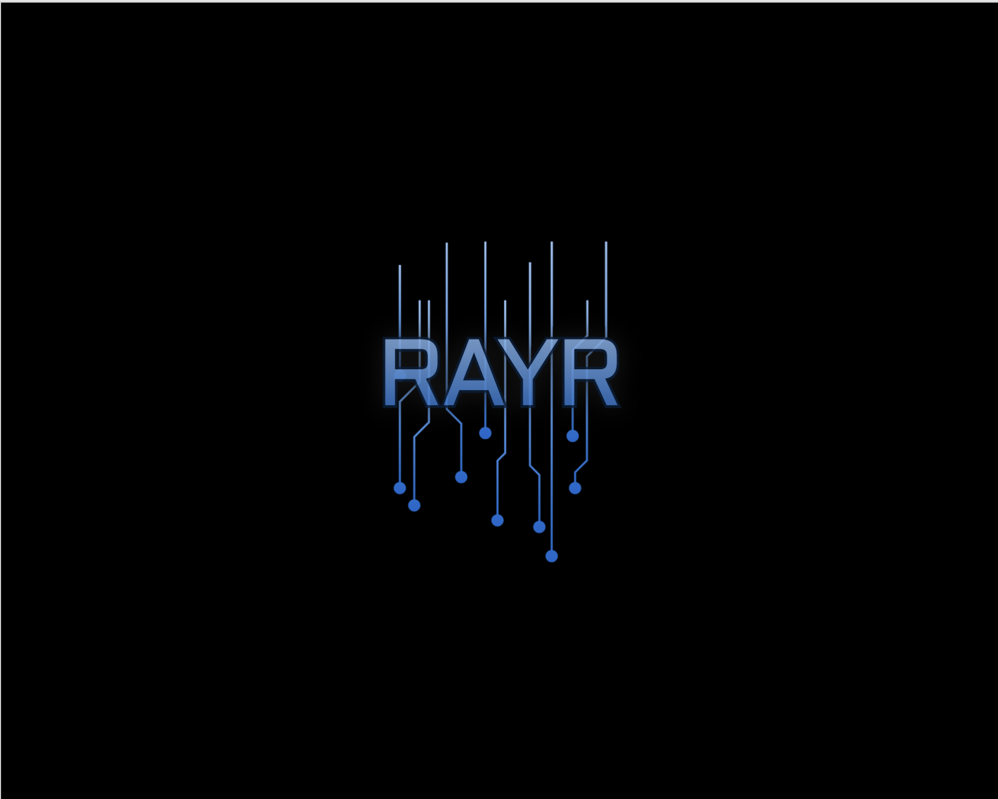

**TEAM REPOSITORY:** [**Github Repo**](https://github.com/Rushabh-Runwal/272_ESP_PROJECT/tree/main)

**List of Ideas for the project**

1. **Data Migration:**  An application for Migrating data from a legacy databases to new databases
2. **Career Help application:** An application where students can connect with alumni, review their resumes, take mock interviews, and get help with other job-related stuff.
3. **Social media platform for Pet owner:** An application where pet owners can get their pets to meet up
4. **Medical History Tracker:** An application where a user keeps track of his medical history, including medication, treatments, and other critical medical information, which the user can share with medical professionals.
5. **YouTube collaborative watch:**  An application that allows users to watch YouTube videos together.